Picture Round
Write your answers on the attached answer sheet. The number of points for each question is given in brackets.




2. Missing vowels: Song titles doubled (4).
e.g. FRTNNTNRMY = FOURTEEN NATION ARMY
1. Name these rom-coms. (4)
SNGFR
DGFTHRTYFR
GHTNTTN
NHNDRDNDNNTYGHTRDBLLNS

3. Name these fictional dogs. (4)

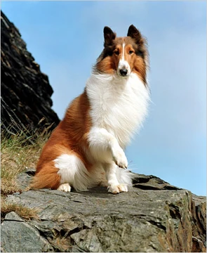

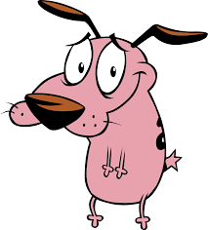
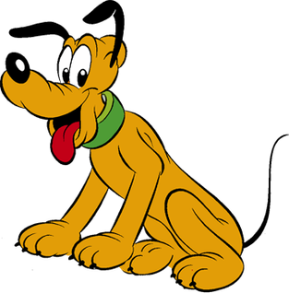

4. Give the common names for these molecules (4)

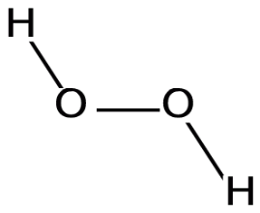

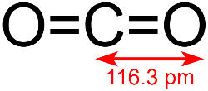

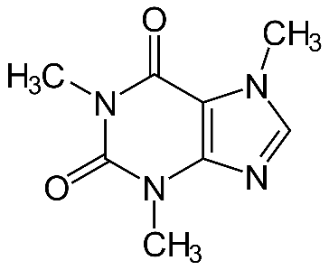
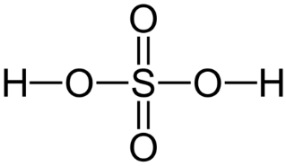
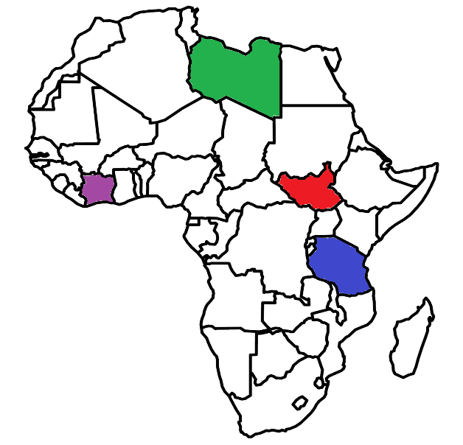
5. Name these African countries. (4)

6. Name these people who have the same initials. (4)

6. Name the Spanish artists from their paintings. (4)
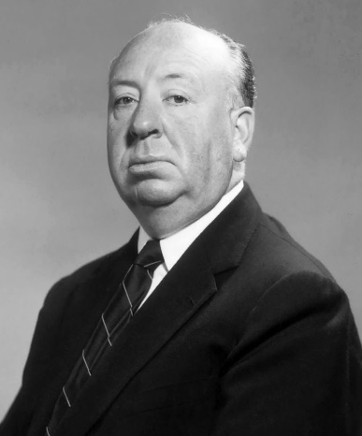


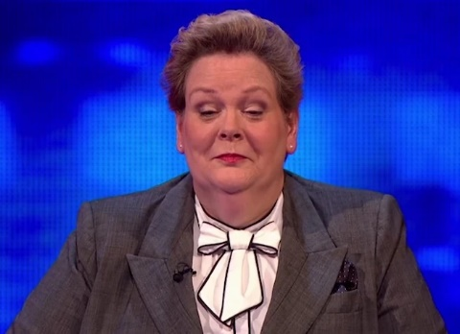





SHARING ELF
OUTRAGE SUPERWOMAN
7. Solve these two anagrams of sea creatures. (2)

7. Solve these two anagrams of cocktails. (2)
8. Identify these logos featuring hearts. (4)

6. Name the Spanish artists from their paintings. (4)

